## Django overview

Django is a Python-based web framework that is specifically engineered to help developers build and construct powerful web applications quickly and efficiently.  The core of the Django framework works with both Python versions 2 and 3. The framework was named after famous guitarist Django Reinhardt.

A framework is a toolbox of components. The reason for using a framework is to prevent written duplicate code for similar tasks. A framework is a library combined with a preset way to organize your code. It’s reusable code bundled in a reusable (but often inflexible) architecture.

Perhaps the best part about Django is its outstanding documentation. Once you learned the basics, You can use the advanced topics because Django has very thorough and readable docs available online.

Django takes much of the tedious work and repetition out of the process, solving questions such as project structure, database object-relational mapping, templating, form validation, sessions, authentication, security, cookie management, internationalization, basic administration, and an interface to access data from scripts.

## Development environment

To create a Django project you need to have python installed on your machine. On Linux and MAC, it has been already installed and is ready to use. In windows, you need to install it first. Go to [python.org](https://www.python.org/) and follow their instructions to install python on your windows machine. We will use Linux Ubuntu 18.04 but all instruction should also work on other versions of Ubuntu including 16.04 and 20.04

## Create and activate virtual environment

A virtual environment, as its name implies, provides the possibility of creating a virtual and isolated environment for test and production of different projects. For example, we have two projects A and B, both of them are Django. We made A project a few years ago and started B recently. A is written with Django version 1.5 and B is made with version. We use Virtual environments so that the two projects do not overlap. This means that any changes you make to the one project environment will not affect the other projects you are developing. For example, if you install and use a specific python package and libraries in one environment doesn’t affect other environments.

Open a terminal and install virtualenv package.

Create virtual environment

virtualenv myenv -p python3

goto scripts folder n run activate.bat file

source ./myenv/bin/activate

pip install django

Create project

Myenv>> django-admin startproject musiclibrary

cd musiclibrary

Myenv>>....\Scripts>>

## Structure of a Django project

On Django, any website that is to be developed is called a “project.” A project consists of a set of “apps”. An app is also a collection of code files that are somehow separate either conceptually or functionally.  If you want to make a website, the whole website will be the Django project. Likely your website will have one or more apps (for example payments, products, accounts,…) Nobody will stop you if you jam all your website functions and codes into one big app inside your project. But it is going to be painful to develop and maintain. It is like creating a house that only has one big room that has everything in it from beds to baths and kitchen and everything. It is more convenient to separate parts of the house into different rooms. In your Django projects, such structures allow developers to have an organized codebase and also reuse applications between different projects since each app is (ideally) independent of other apps.

Django follows the model – template-view (MTV) architectural pattern. The MVT (Model View Template) is a software design pattern. It is a collection of three important components:

* Model
* View
* Template

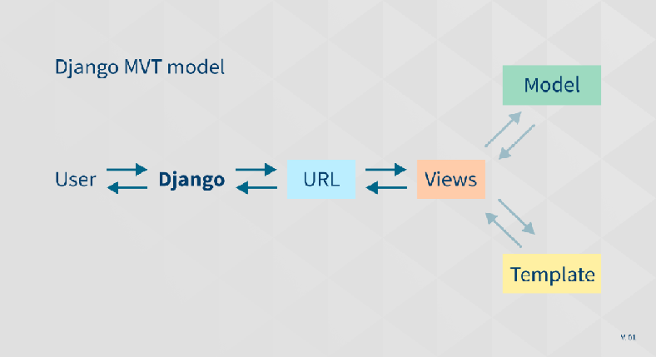

The Django MVT – Model Views Template

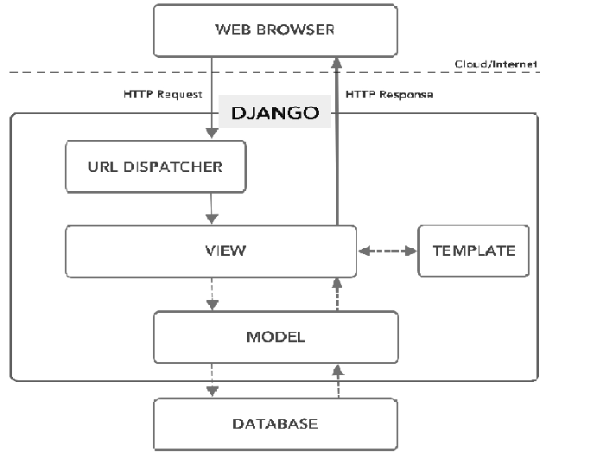

We talked about the contents of our newly created Django project. There were a manage.py file and a folder named musiclibrary. This musiclibrary folder which is inside the musiclibrary project folder (yes they have the same name) is our main app. It has been created by Django automatically and named the same as our Django project (musiclibrary). In general, a Django project

musiclibrary

--manage.py

--musiclibrary

----__init__.py

----manage.py

----settings.py

----urls.py

----wsgi.py

The explanation of the above files is as follows:

**__init__.py:** A file required by Python, This file tells python to view this directory (musiclibrary folder) as python packages. Also, the above file is an empty file, and usually, you will not add anything inside it.

**manage.py**: One of the advantages of the command line is that it allows you to interact with this project in different ways. It allows you to do things like creating users for your website and access to the database. You should never edit or add anything to this file.

**settings.py**: This is a file that contains all of the Settings/configurations for your entire website. Take a look at it to see the available settings, along with the default values.

**urls.py**: To put it simply url.py is like a table of content for the Django website. It will direct the user requests to an appropriate view function to handle them.

**wsgi.py:** This file is used in deploying the project and to help your Django application communicate with the webserver. Much more on this in future sections dedicated to the deployment of Django projects.

## create a view.py file

Django View is one of the essential participants of the Model View Template patterns that we discussed previously. Views act as a bridge between the MODEL and TEMPLATE, in which all the logic of the project is located. By default, views.py won’t be created when you create your project. It is expected of you to create it yourself manually. So go inside the inner musiclibrary folder (main app) and create a file and name it “views.py”. Views.py is just a simple Python file. Inside this file, you will create functions that handle user requests. Functions in views.py, take a Web request and return an HTTP response. They may require information from the models to handle the request.  A view is the part of the program where the “logic” of the program is placed.

Each Django view performs a specific function and usually has an associated template file. In other words, views are responsible for interpreting user requests, transforming or fetching data associated with their requests, and passing along the proper response to the template which communicates the outcome to the user. When you visit a page on the internet or click on some links, the browser sends a request to the backend server. It contains information including headers, parameters, HTTP methods, and sometimes data.

## Write our first Hello World!

Let’s create a simple hello world view to show you how views in Django work. First, we need to define our function with the def keyword. Def is a python registered keyword to define a function. View functions are a specific kind of function that always takes requests as an argument and they should return an HTTP response. There’s nothing special about choosing names for your functions, but it’s a good idea to name it something meaningful to make your code more legible for other developers.

In every website, each of the requests coming to the server should have a response. For example, if a user clicks on the “About” link in doprax.com, the browser makes a request and sends it to the server. There is a view (function) that handles this request and sends back a proper response to the user. This response can be HTML contents of a Web page or a redirect. It also can be a 404 error, or an XML document, or an image. Depending on the request you send different responses will send back to you. Considering this issue, a view’s only purpose is to parse requests to serve a proper response.

The example above was a very simple example of how views work. Most of the time, views do more complex things.  Open the views.py file that you just created and copy-paste this little code snippet in it.

from django.shortcuts import render

from django.http import HttpResponse

​

def hello_world(request):

return HttpResponse("Hello World!")

## URLs in Django

URL stands for **Uniform Resource Locator.**As mentioned before URL is like the table of content of your website. Every page on the Internet needs its own address. It means whenever you create a view, it needs to be mapped to a URL or address. Each view is called by a URL written in the urls.py file inside the main app folder. The default urls.py file inside the main app folder looks something like this.

from django.contrib import admin

from django.urls import path

​

urlpatterns = [

path('admin/', admin.site.urls),

]

The important part of this snippet is the *URL patterns*, which is a python list object. Each item in this list (only one in the above example) is a mapping between an address of a page and a view function that handles it. Let’s add our first URL to the URL patterns list. It should be something like this

Add line in urls.py =🡺 path(‘say-hello/’,views.hello_world),

from django.contrib import admin

from django.urls import path

from .import views

​urlpatterns = [

path('say-hello/', views.hello_world),

path('admin/', admin.site.urls),

​

]

​

Notice that, we have imported views in the third line so that we could reference the hello_world function that we have in the view.py file. We are telling Django that when a request comes to the server and the requested URL is “/say-hello/” (for example http://www.mydomain.com/say-hello/) you should call the hello_world function to handle it.

## Run local development server

Let’s recap what’s happened. We installed the virtualenv package, activated it, and then installed Django using pip. We created our first Django project called musiclibrary. We created our first views function (hello_world) and mapped it to a URL (/say-hello/). Now it is time to run our project and see how it looks like in a browser. Before a request reaches our Django project it needs to be handled by a web server. Thankfully Django comes with a great built-in webserver that has everything we need out of the box.  We just need to run it. Do you remember manage.py file in our project folder? Now it’s time to use it. We will run the webserver using this file.

Make sure that you have activated your virtual environment (myenv) activated. Then make sure you are at the root of the project (~/musiclibrary/). Now enter this command to start Django local development server:

python manage.py runserver

velopment server and by default, it will be reachable using your localhost on port 8000. Open a browser and type this URL or Just cl (<http://127.0.0.1:8000/say-hello/>)

Above steps for creating Django Project:

Below we create Django App:

What is an App?

An app is a web application that has a specific meaning in your project, like a home page, a contact form, or a members database.

In this tutorial we will create an app that allows us to list and register members in a database.

But first, let's just create a simple Django app that displays "Hello World!".

Create App

I will name my app members.

Start by navigating to the selected location where you want to store the app, in my case the my_tennis_club folder, and run the command below.

If the server is still running, and you are not able to write commands, press [CTRL] [BREAK], or [CTRL] [C] to stop the server and you should be back in the virtual environment.

D:\>my_tennis_club> py manage.py startapp members

Django creates a folder named members in my project, with this content:

my_tennis_club  
    manage.py  
    my_tennis_club/  
    members/  
        migrations/  
            __init__.py  
        __init__.py  
        admin.py  
        apps.py  
        models.py  
        tests.py  
        views.py

## Views

Django views are Python functions that takes http requests and returns http response, like HTML documents.

A web page that uses Django is full of views with different tasks and missions.

Views are usually put in a file called views.py located on your app's folder.

There is a views.py in your members folder that looks like this:

my_tennis_club/members/views.py:

from django.shortcuts import render

from django.http import HttpResponse

def members(request):

return HttpResponse("Hello world!")

## URLs

Create a file named urls.py in the same folder as the views.py file, and type this code in it:

my_tennis_club/members/urls.py:

from django.urls import path

from . import views

urlpatterns = [

path('members/', views.members, name='members'),

]

The urls.py file you just created is specific for the members application. We have to do some routing in the root directory my_tennis_club as well. This may seem complicated, but for now, just follow the instructions below.

There is a file called urls.py on the my_tennis_club folder, open that file and add the include module in the import statement, and also add a path() function in the urlpatterns[] list, with arguments that will route users that comes in via 127.0.0.1:8000/.

Then your file will look like this:

my_tennis_club/my_tennis_club/urls.py:

from django.contrib import admin

from django.urls import include, path

urlpatterns = [

path('', include('members.urls')),

path('admin/', admin.site.urls),

]

If the server is not running, navigate to the /my_tennis_club folder and execute this command in the command prompt:

py manage.py runserver

In the browser window, type [127.0.0.1:8000/members/](http://127.0.0.1:8000/members/) in the address bar.

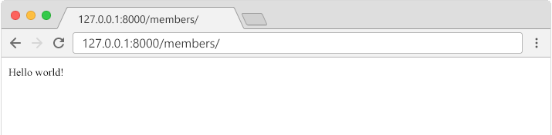

## Templates

In the [Django Intro](https://www.w3schools.com/django/django_intro.php) page, we learned that the result should be in HTML, and it should be created in a template, so let's do that.

Create a templates folder inside the members folder, and create a HTML file named myfirst.html.

The file structure should be like this:

my_tennis_club  
    manage.py  
    my_tennis_club/  
    members/  
        templates/  
            myfirst.html

Open the HTML file and insert the following:

my_tennis_club/members/templates/myfirst.html:

<!DOCTYPE html>

<html>

<body>

<h1>Hello World!</h1>

<p>Welcome to my first Django project!</p>

</body>

</html>

## Modify the View

Open the views.py file and replace the members view with this:

my_tennis_club/members/views.py:

from django.http import HttpResponse

from django.template import loader

def members(request):

template = loader.get_template('myfirst.html')

return HttpResponse(template.render())

## Change Settings

To be able to work with more complicated stuff than "Hello World!", We have to tell Django that a new app is created.

This is done in the settings.py file in the my_tennis_club folder.

Look up the INSTALLED_APPS[] list and add the members app like this:

my_tennis_club/my_tennis_club/settings.py:

INSTALLED_APPS = [

'django.contrib.admin',

'django.contrib.auth',

'django.contrib.contenttypes',

'django.contrib.sessions',

'django.contrib.messages',

'django.contrib.staticfiles',

'members'

]

Then run this command:

py manage.py migrate

Which will produce this output:

Operations to perform:  
  Apply all migrations: admin, auth, contenttypes, sessions  
Running migrations:  
  Applying contenttypes.0001_initial... OK  
  Applying auth.0001_initial... OK  
  Applying admin.0001_initial... OK  
  Applying admin.0002_logentry_remove_auto_add... OK  
  Applying admin.0003_logentry_add_action_flag_choices... OK  
  Applying contenttypes.0002_remove_content_type_name... OK  
  Applying auth.0002_alter_permission_name_max_length... OK  
  Applying auth.0003_alter_user_email_max_length... OK  
  Applying auth.0004_alter_user_username_opts... OK  
  Applying auth.0005_alter_user_last_login_null... OK  
  Applying auth.0006_require_contenttypes_0002... OK  
  Applying auth.0007_alter_validators_add_error_messages... OK  
  Applying auth.0008_alter_user_username_max_length... OK  
  Applying auth.0009_alter_user_last_name_max_length... OK  
  Applying auth.0010_alter_group_name_max_length... OK  
  Applying auth.0011_update_proxy_permissions... OK  
  Applying auth.0012_alter_user_first_name_max_length... OK  
  Applying sessions.0001_initial... OK  
  
(myworld) C:\Users\Your Name\myworld\my_tennis_club>

Start the server by navigating to the /my_tennis_club folder and execute this command:

py manage.py runserver

In the browser window, type [127.0.0.1:8000/members/](http://127.0.0.1:8000/members/) in the address bar.

The result should look like this:

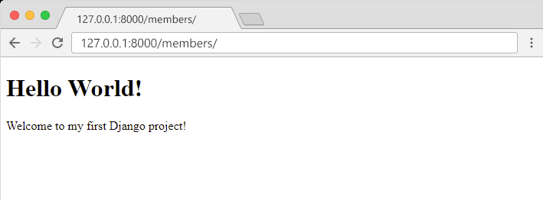

Django Models

Up until now in this tutorial, output has been static data from Python or HTML templates.

Now we will see how Django allows us to work with data, without having to change or upload files in the prosess.

In Django, data is created in objects, called Models, and is actually tables in a database.

Create Table (Model)

To create a model, navigate to the models.py file in the /members/ folder.

Open it, and add a Member table by creating a Member class, and describe the table fields in it:

my_tennis_club/members/models.py:

from django.db import models

class Member(models.Model):

firstname = models.CharField(max_length=255)

lastname = models.CharField(max_length=255)

The first field, firstname, is a Text field, and will contain the first name of the members.

The second field, lastname, is also a Text field, with the member's last name.

Both firstname and lastname is set up to have a maximum of 255 characters.

SQLite Database

When we created the Django project, we got an empty SQLite database.

It was created in the my_tennis_club root folder, and has the filename db.sqlite3.

By default, all Models created in the Django project will be created as tables in this database.

Migrate

Now when we have described a Model in the models.py file, we must run a command to actually create the table in the database.

Navigate to the /my_tennis_club/ folder and run this command:

py manage.py makemigrations members

Which will result in this output:

Migrations for 'members':  
  members\migrations\0001_initial.py  
    - Create model Member  
  
(myworld) C:\Users*Your Name*\myworld\my_tennis_club>

Django creates a file describing the changes and stores the file in the /migrations/ folder:

**my_tennis_club/members/migrations/0001_initial.py:**

# Generated by Django 4.1.2 on 2022-10-27 11:14

from django.db import migrations, models

class Migration(migrations.Migration):

initial = True

dependencies = [

]

operations = [

migrations.CreateModel(

name='Member',

fields=[

('id', models.BigAutoField(auto_created=True, primary_key=True, serialize=False, verbose_name='ID')),

('firstname', models.CharField(max_length=255)),

('lastname', models.CharField(max_length=255)),

],

),

]

Note that Django inserts an id field for your tables, which is an auto increment number (first record gets the value 1, the second record 2 etc.), this is the default behavior of Django, you can override it by describing your own id field.

The table is not created yet, you will have to run one more command, then Django will create and execute an SQL statement, based on the content of the new file in the /migrations/ folder.

Run the migrate command:

py manage.py migrate

Which will result in this output:

Operations to perform:  
  Apply all migrations: admin, auth, contenttypes, members, sessions  
Running migrations:  
  Applying members.0001_initial... OK  
  
(myworld) C:\Users*Your Name*\myworld\my_tennis_club>

Now you have a Member table in you database!

View SQL

As a side-note: you can view the SQL statement that were executed from the migration above. All you have to do is to run this command, with the migration number:

py manage.py sqlmigrate members 0001

Which will result in this output:

BEGIN;  
--  
-- Create model Member  
--  
CREATE TABLE "members_member" ("id" integer NOT NULL PRIMARY KEY AUTOINCREMENT, "firstname" varchar(255) NOT NULL, "lastname" varchar(255) NOT NULL); COMMIT;

## Add Records

To open a Python shell, type this command:

**py manage.py shell**

Now we are in the shell, the result should be something like this:

Python 3.9.2 (tags/v3.9.2:1a79785, Feb 19 2021, 13:44:55) [MSC v.1928 64 bit (AMD64)] on win32  
Type "help", "copyright", "credits" or "license" for more information.  
(InteractiveConsole)  
>>>

At the bottom, after the three >>> write the following:

>>> from members.models import Member

Hit [enter] and write this to look at the empty Member table:

>>> Member.objects.all()

This should give you an empty QuerySet object, like this:

<QuerySet []>

A QuerySet is a collection of data from a database.

Read more about QuerySets in the [Django QuerySet](https://www.w3schools.com/django/django_queryset.php) chapter.

Add a record to the table, by executing these two lines:

>>> member = Member(firstname='Srikar', lastname='Thangella')  
>>> member.save()

Execute this command to see if the Member table got a member:

>>> Member.objects.all().values()

Hopefully, the result will look like this:

<QuerySet [{'id': 1, 'firstname': 'Srikar', 'lastname': 'Thangella'}]>

Adding multiple records:

>>> member1 = Member(firstname='Tobias', lastname='Refsnes')  
>>> member2 = Member(firstname='Linus', lastname='Refsnes')  
>>> member3 = Member(firstname='Lene', lastname='Refsnes')  
>>> member4 = Member(firstname='Stale', lastname='Refsnes')  
>>> member5 = Member(firstname='Jane', lastname='Doe')  
>>> members_list = [member1, member2, member3, member4, member5]  
>>> for x in members_list:  
>>>   x.save()

To view the multiple records added:

Member.objects.all().values()  
<QuerySet [{'id': 1, 'firstname': 'Emil', 'lastname': 'Refsnes'},  
{'id': 2, 'firstname': 'Tobias', 'lastname': 'Refsnes'},  
{'id': 3, 'firstname': 'Linus', 'lastname': 'Refsnes'},  
{'id': 4, 'firstname': 'Lene', 'lastname': 'Refsnes'},  
{'id': 5, 'firstname': 'Stale', 'lastname': 'Refsnes'},  
{'id': 6, 'firstname': 'Jane', 'lastname': 'Doe'}]>

## Create Template

After creating Models, with the fields and data we want in them, it is time to display the data in a web page.

Start by creating an HTML file named all_members.html and place it in the /templates/ folder:

my_tennis_club/members/templates/all_members.html:

<!DOCTYPE html>

<html>

<body>

<h1>Members</h1>

<ul>

{% for x in mymembers %}

<li>{{ x.firstname }} {{ x.lastname }}</li>

{% endfor %}

</ul>

<h1>Members</h1>

<ul>

{% for x in mymembers %}

<li><a href="details/{{ x.id }}">{{ x.firstname }} {{ x.lastname }}</a></li>

{% endfor %}

</ul>

</body>

</html>

Do you see the {% %} brackets inside the HTML document?

They are Django Tags, telling Django to perform some programming logic inside these brackets.

Start by creating a new template called details.html:

my_tennis_club/members/templates/details.html:

<!DOCTYPE html>

<html>

<body>

<h1>{{ mymember.firstname }} {{ mymember.lastname }}</h1>

<p>Back to <a href="/members">Members</a></p>

</body>

</html>

Create new View

Then create a new view in the views.py file, that will deal with incoming requests to the /details/ url:

my_tennis_club/members/views.py:

from django.http import HttpResponse

from django.template import loader

from .models import Member

def members(request):

mymembers = Member.objects.all().values()

template = loader.get_template('all_members.html')

context = {

'mymembers': mymembers,

}

return HttpResponse(template.render(context, request))

def details(request, id):

mymember = Member.objects.get(id=id)

template = loader.get_template('details.html')

context = {

'mymember': mymember,

}

return HttpResponse(template.render(context, request))

The details view does the following:

* Gets the id as an argument.
* Uses the id to locate the correct record in the Member table.
* loads the details.html template.
* Creates an object containing the member.
* Sends the object to the template.
* Outputs the HTML that is rendered by the template.

## Add URLs

Now we need to make sure that the /details/ url points to the correct view, with id as a parameter.

Open the urls.py file and add the details view to the urlpatterns list:

my_tennis_club/members/urls.py:

from django.urls import path

from . import views

urlpatterns = [

path('members/', views.members, name='members'),

path('members/details/<int:id>', views.details, name='details'),

]

[Run Example »](https://www.w3schools.com/django/showdjango.php?filename=demo_add_link_details)

If you have followed all the steps on your own computer, you can see the result in your own browser: [127.0.0.1:8000/members/](http://127.0.0.1:8000/members/).

If the server is down, you have to start it again with the runserver command:

py manage.py runserver

[127.0.0.1:8000/members/](http://127.0.0.1:8000/members/)details/1